## Overview

In this activity, you will practice rotating and scaling prebuilt elements on your page.

These effects will help you build engaging interfaces, especially in combination with upcoming activities.

## Instructions

**Step 1: Rotate**

1. Open the index.html and index.css files.
   * **Note:** You can find the file located within the .zip file in the Activities folder.
2. Inside index.css, find the selector that targets images nested in an element with the rotate class.
3. Add transform: rotate(180deg); to this selector. (This will flip the image of the dog on its head.)

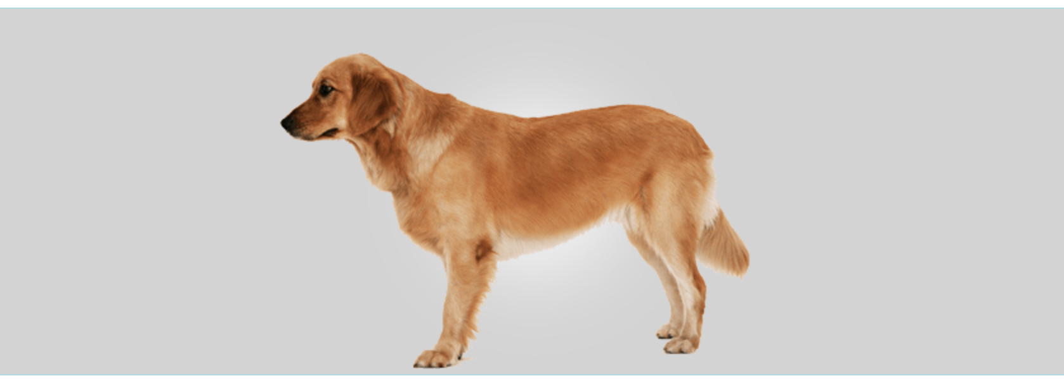

1. Try other values (even negative numbers) for rotate and see what happens.

**Step 2: Scale**

1. Find the .scaleMe selector and give this a property of transform: scale(2); (this will increase the size of the red square).
2. Try out scaling along the x- and y-axes using scaleX() and scaleY() or the shorthand of scale(x,y).

**Step 3: Translate**

1. Find the .moveMe selector and give this a property of transform: translate(80%, 40%);.
   * **Note:** You should see the blue square move from the left by the first value and the top by the second value.
2. Try out translate along the x- and y-axes using translateX() and translateY() or the shorthand of scale(x,y).
3. You should have a box that scales and moves along the x- and y-axes.

**Bonus**

1. If you’d like to take your work a step further, try out other two- and three-dimensional transformations. Read more about that [here](https://developer.mozilla.org/en-US/docs/Web/CSS/transform).